Areas of Common Shapes

Triangle: A three sided figure.
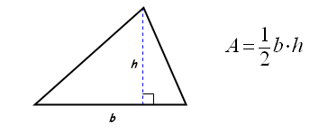

Rectangle: A quadrilateral with four right angles.
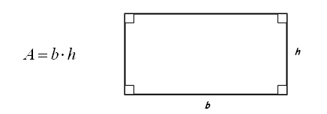

Parallelogram: A quadrilateral with two pairs of opposite sides parallel.
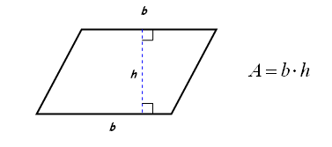

Trapezoid: A quadrilateral with exactly one pair of opposite sides parallel.
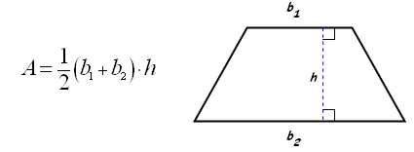

Circle: A set of points all equidistant from a given point - the center.
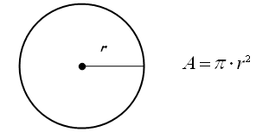

Any Regular Polygon: A figure with all sides and angles congruent.
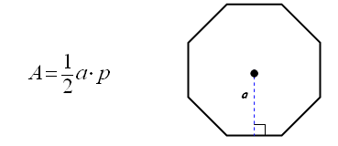
(p = perimeter)

Area and Perimeter of Irregular Shapes
To find the area and perimeter of irregular shapes, the first thing to do is to divide the irregular shape into regular shapes that you can recognize such as triangles, rectangles, circles, squares and so forth...
Example—Find the area of this shape:
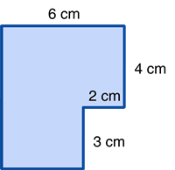
This can be done in two different ways:
Method #1 | Method #2
Divide the figure into two rectangles and find all missing lengths.  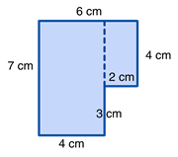  The larger rectangle has an area of  4 cm x 7 cm = 28 cm²  The smaller rectangle has an area of  4 cm x 2 cm = 8 cm²  If we combine these we will find the total area:  28 cm² + 8 cm² = 36 cm² | Draw two lines to make the figure into one large rectangle.  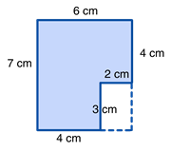  The area of the large rectangle is  7 cm x 6 cm = 42 cm²  However, a 2 cm x 3 cm rectangle is not included in our original figure, so we need to take out the area of the white rectangle (2 cm x 3 cm = 6 cm²)  42 cm² - 6 cm² = 36 cm²

Example #2—Find the perimeter of this shape:
Wait, some sides are missing! No problem, we can fill those by adding together or subtracting the opposite sides.
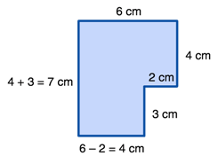
Now find the sum of all sides:

6 + 4 + 2 + 3 + 4 + 7 = 26 cm

Last Example—Find the area of this shape:
The figure above has three regular shapes. Starting from top to bottom, it has a triangle, a rectangle, and a trapezoid. Find the area for each of those three shapes and add the results
Area of the Triangle = ½ bh = ½ 3 x 4 = 6
Area of the Rectangle = length x width = 3 x 10 = 30
Area of the Trapezoid = ½ (b₁ + b₂) x h = ½ (3 + 5) x 2 = 8
Total area = 6 + 30 + 8 = 44 square units

