Compound Probability
Compound probabilities, also known as multiple probabilities, are the probability of 2 or more things happening.
The probability of 2 (or more) independent things happening, either one after the other or together, is the probability of the first thing happening multiplied by the probability of the second thing happening (multiplied by the third, and the fourth, etc.).
Example 1: Flipping a coin 2 times:
What is the probability of flipping a coin 2 times and it coming up "heads" both times?
First toss |  | Second toss
$$\frac{1}{2}$$ | x | $$\frac{1}{2}$$ | = | $$\frac{1}{4}$$ | or 1 chance in 4 tries

Note: This answer of 1/4 is correct before you make the first toss. After you toss the coin once, and it comes up heads, the probability that the second toss will also come up heads is 1/2 because the first toss is in the past.
Example 2: Drawing 2 cards at the same time
What is the probability of drawing 2 aces in a row out of a deck of 52 cards, if you don't put the first card back in the deck before drawing the second card?
First draw |  | Second draw
$$\frac{4}{52}$$ | x | $$\frac{3}{51}$$ | = | $\frac{12}{2652}$ = $\frac{1}{221}$ | or 1 chance in 221 tries

Why is the probability of the second ace 3/51?
Well, after you draw the first ace (you assume you got it) there are only 3 aces left and 51 cards.

Example 3: Drawing 2 cards with replacement
How would the probabilities change if you had put the first ace back in the deck before drawing the second time? Well, this makes the probability of drawing an ace on the second draw the same as on the first draw, so the probability of drawing 2 aces with replacement of the first ace is:
First draw |  | Second draw
$$\frac{4}{52}$$ | x | $$\frac{4}{52}$$ | = | $\frac{16}{2704}$ = $\frac{1}{169}$ | or 1 chance in 169 tries

Since $\frac{1}{169}$ is larger than$\frac{1}{221}$, this means you are more likely to get 2 aces in a row if you put your first ace back in the deck before you draw your second card. But you knew that!

Probability Trees
Calculating probabilities can be hard, sometimes you add them, sometimes you multiply them, and often it is hard to figure out what to do ... tree diagrams to the rescue!
Here is a tree diagram for the toss of a coin:
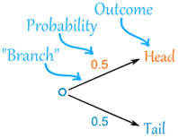 |  | There are two "branches" (Heads and Tails)  - The probability of each branch is written on the branch  - The outcome is written at the end of the branch
We can extend the tree diagram to two tosses of a coin:
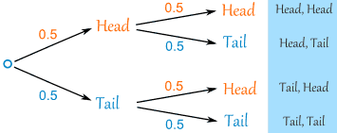

How do you calculate the overall probabilities?
- You multiply probabilities along the branches
- You add probabilities down columns

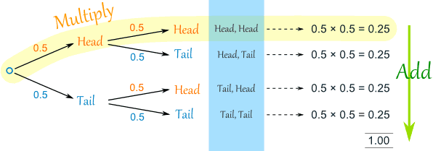

Now we can see such things as:
- The probability of "Head, Head" is 0.5×0.5 = 0.25
- All probabilities add to 1.0 (which is always a good check)
- The probability of getting at least one Head from two tosses is 0.25+0.25+0.25 = 0.75
- ... and more
That was a simple example using independent events (each toss of a coin is independent of the previous toss), but tree diagrams are really wonderful for figuring out dependent events (where an event depends on what happens in the previous event) like this example:

Example: Soccer Game
You are off to soccer, and love being the Goalkeeper, but that depends who is the Coach today:
- with Coach Sam the probability of being Goalkeeper is 0.5
- with Coach Alex the probability of being Goalkeeper is 0.3
Sam is Coach more often ... about 6 out of every 10 games (a probability of 0.6).
So, what is the probability you will be a Goalkeeper today?

Let's build the tree diagram. First we show the two possible coaches: Sam or Alex:
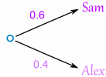
The probability of getting Sam is 0.6, so the probability of Alex must be 0.4 (together the probability is 1)
Now, if you get Sam, there is 0.5 probability of being Goalie (and 0.5 of not being Goalie):
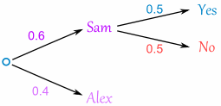
If you get Alex, there is 0.3 probability of being Goalie (and 0.7 not):
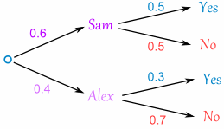
The tree diagram is complete; now let's calculate the overall probabilities. This is done by multiplying each probability along the "branches" of the tree.
Here is how to do it for the "Sam, Yes" branch:
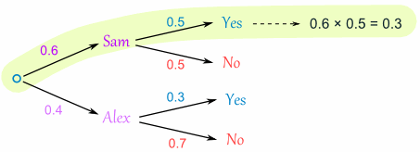
(When we take the 0.6 chance of Sam being coach and include the 0.5 chance that Sam will let you be Goalkeeper we end up with a 0.3 chance.)
But we are not done yet! We haven't included Alex as Coach:
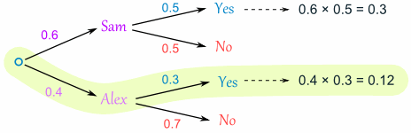
A 0.4 chance of Alex as Coach, followed by a 0.3 chance gives 0.12.
Now we add the column:
0.3 + 0.12 = 0.42 probability of being a Goalkeeper today
(That is a 42% chance)

Check Your Results
One final step: complete the calculations and make sure they add to 1:
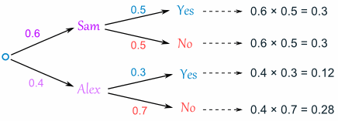
0.3 + 0.3 + 0.12 + 0.28 = 1
Yes, it all adds up.

Conclusion
So there you go, when in doubt draw a tree diagram, multiply along the branches and add the columns. Make sure all probabilities add to 1 and you are good to go.

