Alternate Interior Angles
For any pair of parallel lines 1 and 2, that are both intersected by a third line, such as line 3 in the diagram below, angle A and angle D are called alternate interior angles. Alternate interior angles have the same degree measurement. Angle B and angle C are also alternate interior angles.
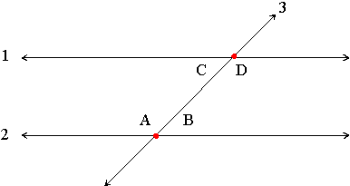

Alternate Exterior Angles
For any pair of parallel lines 1 and 2, that are both intersected by a third line, such as line 3 in the diagram below, angle A and angle D are called alternate exterior angles. Alternate exterior angles have the same degree measurement. Angle B and angle C are also alternate exterior angles.
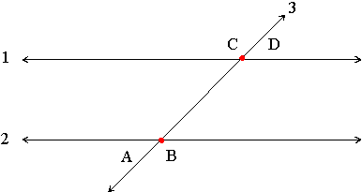

Corresponding Angles
For any pair of parallel lines 1 and 2, that are both intersected by a third line, such as line 3 in the diagram below, angle A and angle C are called corresponding angles. Corresponding angles have the same degree measurement. Angle B and angle D are also corresponding angles.
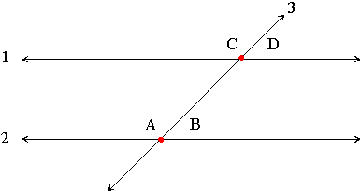

Angles Around a Point

Angles around a point will always add up to 360 degrees.

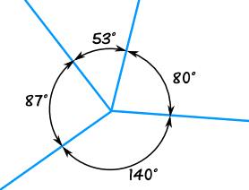

The angles above all add to 360°
53° + 80° + 140° + 87° = 360°

The Coordinate Plane
This is a coordinate plane. It has two axes and four quadrants. The two number lines form the axes. The horizontal number line is called the x-axis and the vertical number line is called the y-axis.  The center of the coordinate plane is called the origin. It has the coordinates of (0,0).  Locations of points on the plane can be plotted when one coordinate from each of the axes are used. This set of x and y values are called ordered pairs. | 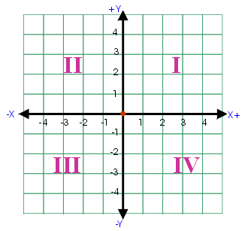
Suppose you were told to locate "(5, 2)" (pronounced as "the point five two" or just "five two") on the coordinate plane. Where would you look? To understand the meaning of "(5, 2)", you have to know the following rule: The x-coordinate (the number for the x-axis) always comes first. The first number (the first coordinate) is always on the horizontal axis.

So, for the point (5, 2), you would start at the "origin", the spot where the axes cross: | 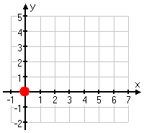 | ...then count over to "five" on the x-axis: | 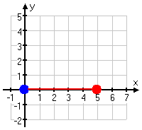
...then count up to "two", moving parallel to the y-axis: | 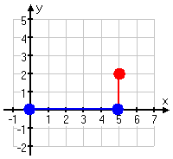 | ...and then draw in the dot: | 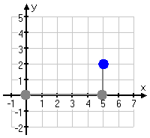
Finding the location of (5, 2) and then drawing its dot is called "plotting the point (5, 2)".
Cogito, ergo sum. | René Descartes (1596-1650)  The French philosopher, mathematician, and scientist Rene Descartes, was one of the most important and influential thinkers in history. Descartes founded analytic geometry and originated the Cartesian coordinates and Cartesian curves. The coordinate plane is often called the Cartesian plane.

