The Pythagorean Theorem
One of the most interesting and well-known formulas in math is the Pythagorean Theorem, which only holds true for right triangles. The formula says that the length of the hypotenuse (the longest side) squared is equal to the sum of the squares of the lengths of the legs:
c ² = a ² + b ²

If a triangle is right, then this formula holds true. Conversely, if this formula holds true, then you know that the triangle for which it works is a right triangle. With this formula, given any two sides of a right triangle, you can calculate the length of the third side. One way to picture it can be seen below.

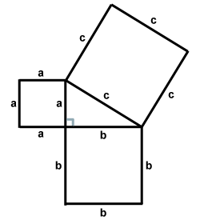
The Pythagorean Theorem

In the figure above, the area of the square with side length c is equal to the sum of the areas of the squares with side lengths a and b. This is a physical interpretation of the Pythagorean Theorem.

The three sides of a right triangle can be of any length, provided that they obey the laws of the Pythagorean Theorem.

Pythagorean Practice

Use the diagram below to answer the following questions:
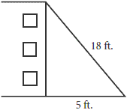
- How far up a building will an 18-foot ladder reach if the ladder's base is 5 feet from the building? Express your answer to the nearest foot. Solve the problem when the ladder is 3 feet from the building. Why would it be impractical to solve the problem if the base of the ladder was closer than 3 feet from the building?

- If instead of an 18-foot ladder, a 25-foot ladder was used, how far would the ladder need to be from the base of the building in order for it to reach a window that is 20 feet from the ground?

- If a ladder is going to be placed 6 feet from the base of the wall and needs to reach a window that is 8 feet from the ground, how long must the ladder be?

Answers:

- When the ladder is placed 5 feet from the building, the ladder extends a little over 17 feet up the building. When the ladder is placed 3 feet from the building, it reaches about 17 $\frac{3}{4}$ feet up the building. It would be impractical to place the ladder that close or even closer because it would not be stable. You would not go very far up the ladder before you would be falling back down!

- The ladder would need to be 15 feet from the base of the wall. (15² + 20² = 25²)

- The ladder would need to be 10 feet tall. (6² + 8² = 10²)

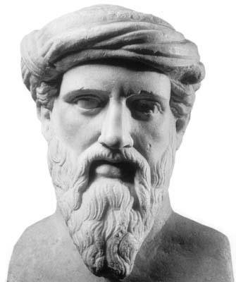
Pythagoras (569-500 B.C.E.) was born on the island of Samos in Greece, and did much traveling through Egypt, learning, among other things, mathematics. Not much more is known of his early years. Pythagoras gained his famous status by founding a group, the Brotherhood of Pythagoreans, which was devoted to the study of mathematics. The group was almost cult-like in that it had symbols, rituals and prayers. In addition, Pythagoras believed that "Number rules the universe," and the Pythagoreans gave numerical values to many objects and ideas. These numerical values, in turn, were endowed with mystical and spiritual qualities.
Legend has it that upon completion of his famous theorem, Pythagoras sacrificed 100 oxen. Although he is credited with the discovery of the famous theorem, it is not possible to tell if Pythagoras is the actual author. The Pythagoreans wrote many geometric proofs, but it is difficult to ascertain who proved what, as the group wanted to keep their findings secret. Unfortunately, this vow of secrecy prevented an important mathematical idea from being made public. The Pythagoreans had discovered irrational numbers! If we take an isosceles right triangle with legs of measure 1, the hypotenuse will measure$\sqrt{2}$. But this number cannot be expressed as a length that can be measured with a ruler divided into fractional parts, and that deeply disturbed the Pythagoreans, who believed that "All is number." They called these numbers "alogon," which means "unutterable." So shocked were the Pythagoreans by these numbers, they put to death a member who dared to mention their existence to the public. It would be 200 years later that the Greek mathematician Eudoxus developed a way to deal with these unutterable numbers.

