All About Quadrilaterals
All quadrilaterals have four sides (edges) and four vertices (corners).
The interior angles of a quadrilateral always add up to 360˚.

The Rectangle
 |  | means "right angle"
 | and | show equal sides
A rectangle is a four-sided shape where every angle is a right angle (90°).
Also opposite sides are parallel and of equal length.

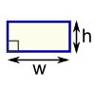 | Rectangle  Area = w × h  w = width  h = height

The Rhombus
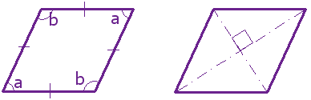
A rhombus is a four-sided shape where all sides have equal length.
Also opposite sides are parallel and opposite angles are equal.
Another interesting thing is that the diagonals (dashed lines in second figure) of a rhombus bisect each other at right angles.

The Square
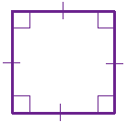
means "right angle"
show equal sides
A square has equal sides and every angle is a right angle (90°)
Also opposite sides are parallel.
A square also fits the definition of a rectangle (all angles are 90°), and a rhombus (all sides are equal length).

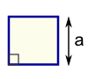 | Square  Area = a²  a = length of side

The Parallelogram
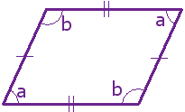
Opposite sides are parallel and equal in length, and opposite angles are equal (angles "a" are the same, and angles "b" are the same)

NOTE: Squares, Rectangles and Rhombuses are all Parallelograms!

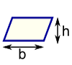 | Parallelogram  Area = b × h  b = base  h = vertical height

The Trapezoid

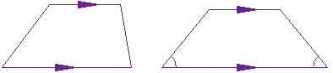
Trapezoid | Isosceles Trapezoid
A trapezoid has one pair of opposite sides parallel. It is called an Isosceles trapezoid if the sides that aren't parallel are equal in length and both angles coming from a parallel side are equal, as shown.

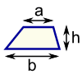 | Trapezoid  Area = ½(a+b) × h  h = vertical height

The Kite
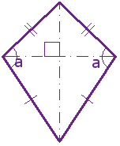
Hey, it looks like a kite. It has two pairs of sides. Each pair is made up of adjacent sides that are equal in length. The angles are equal where the pairs meet. Diagonals (dashed lines) meet at a right angle, and one of the diagonal bisects (cuts equally in half) the other.

Irregular Quadrilaterals

The only regular quadrilateral is a square. So all other quadrilaterals are irregular.

All About Polygons
Polygons are 2-dimensional shapes. They are made of straight lines, and the shape is "closed" (all the lines connect up).
 |  | 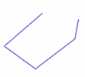
Polygon  (straight sides) | Not a Polygon  (has a curve) | Not a Polygon  (open, not closed)

The word “polygon” comes from Greek. “Poly-“ means “many” and “-gon” means “angle”.

Types of Polygons

Simple or Complex
A simple polygon has only one boundary, and it doesn't cross over itself. A complex polygon intersects itself!
Simple Polygon  (this one's a Pentagon) | Complex Polygon  (also a Pentagon)

Concave or Convex
A convex polygon has no angles pointing inwards. More precisely, no internal angles can be more than 180°.
If there are any internal angles greater than 180° then it is concave. (Think: concave has a "cave" in it)
Convex | Concave

Regular or Irregular
If all angles are equal and all sides are equal, then it is regular, otherwise it is irregular
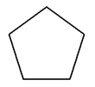
Regular | Irregular

More Examples
Complex Polygon  (a "star polygon", in  this case, a pentagram) | Concave Octagon | Irregular Hexagon

Interior Angles

When you begin with a simple polygon with four or more sides and draw all the diagonals possible from one vertex, the polygon then is divided into several non-overlapping triangles. The figure below illustrates this division using a seven-sided polygon. The interior angle sum of this polygon can now be found by multiplying the number of triangles by 180°.

5 triangles x 180˚ = 900˚. The interior angles of a heptagon add up to 900˚.

Exterior Angles
Finding the sum of the exterior angles of a simple polygon is easy. No matter what type of polygon you have, the sum of the exterior angles is ALWAYS equal to 360°.
If you are working with a regular polygon, you can determine the size of EACH exterior angle by simply dividing the sum, 360, by the number of angles. Remember, this will ONLY work in a regular polygon.
Example: What is the size of one of the exterior angles of a regular pentagon?

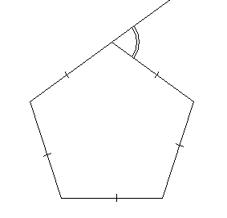 | 360˚ ÷ 5 (the number of angles in a pentagon) = 72˚, so the measurement of each exterior angle of a regular pentagon is 72˚. Note that the exterior angle is a complement to the interior angle of the pentagon, so it is also easy to see that each interior angle of a regular pentagon measures 108˚.

Name that Polygon!
 |  | If it is a Regular Polygon... |  | For polygons with 13 or more sides, it is OK (and easier) to write “13-gon”, “14-gon”…”100-gon”, etc.  What shape would a Googolgon most resemble?
Name | Sides | Interior Angle
Triangle (or Trigon) | 3 | 60°
Quadrilateral (or Tetragon) | 4 | 90°
Pentagon | 5 | 108°
Hexagon | 6 | 120°
Heptagon (or Septagon) | 7 | 128.571°
Octagon | 8 | 135°
Nonagon (or Enneagon) | 9 | 140°
Decagon | 10 | 144°
Hendecagon (or Undecagon) | 11 | 147.273°
Dodecagon | 12 | 150°
Triskaidecagon | 13 | 152.308°
Tetrakaidecagon | 14 | 154.286°
Pentadecagon | 15 | 156°
Hexakaidecagon | 16 | 157.5°
Heptadecagon | 17 | 158.824°
Octakaidecagon | 18 | 160°
Enneadecagon | 19 | 161.053°
Icosagon | 20 | 162°
Triacontagon | 30 | 168°
Tetracontagon | 40 | 171°
Pentacontagon | 50 | 172.8°
Hexacontagon | 60 | 174°
Heptacontagon | 70 | 174.857°
Octacontagon | 80 | 175.5°
Enneacontagon | 90 | 176°
Hectagon | 100 | 176.4°
Chiliagon | 1,000 | 179.64°
Myriagon | 10,000 | 179.964°
Megagon | 1,000,000 | ~180°
Googolgon | 10¹⁰⁰ | ~180°
n-gon | n | (n-2) × 180° / n

All About Circles

The definition of a circle is:
The set of all points on a plane that are a fixed distance from a center.

Radius and Diameter  The Radius is the distance from the center to the edge.  The Diameter starts at one side of the circle, goes through the center and ends on the other side.  So the Diameter is twice the Radius:  Diameter = 2 × Radius | 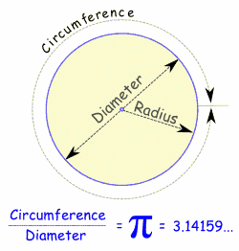

Circumference

The Circumference is the distance around the edge of the circle.

It is exactly Pi (the symbol is π) times the Diameter, so:

Circumference = π × Diameter

And so these are also true:
Circumference = 2 × π × Radius
Circumference / Diameter = π

Area  The area of a circle is π times the Radius squared, which is written:  A = π × r²  Or, in terms of the Diameter:  A = (π/4) × D²  It is easy to remember if you think of the area of the square that the circle would fit inside. | 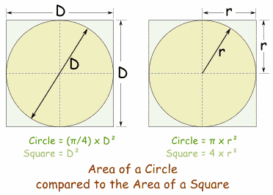

Parts of a Circle

Because people have studied circles for thousands of years special names have come about.
Nobody wants to say "that line that starts at one side of the circle, goes through the center and ends on the other side" when a word like "Diameter" would do.

So here are the most common special names:

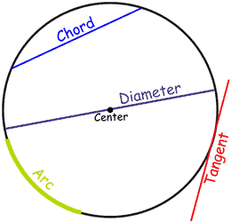 | Lines  A line that goes from one point to another on the circle's circumference is called a Chord.  If that line passes through the center it is called a Diameter.  If a line "just touches" the circle as it passes it is called a Tangent.  And a part of the circumference is called an Arc.

Slices  There are two main "slices" of a circle  The "pizza" slice is called a Sector.  And the slice made by a chord is called a Segment. | 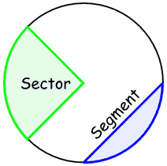

Common Sectors

The Quadrant and Semicircle are two special types of Sector:

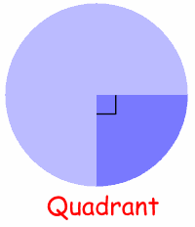 | One quarter of a circle is called a Quadrant.  Half a circle is called a Semicircle.

Inside and Outside
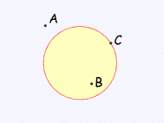 | Riddle: How many sides does a circle have? Two! An inside and an outside.  A circle has an inside and an outside (of course!). But it also has an "on", because you could be right on the circle.  Example: "A" is outside the circle, "B" is inside the circle and "C" is on the circle.

