Volume
The volume of a three-dimensional figure is the amount of space the figure occupies. Volume is always measured in cubic units, such as in³ or cm³.
The volume (V) of many solids can be found by multiplying the area of the solid’s base by its height. For example:
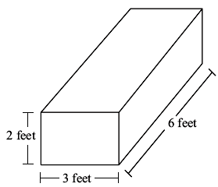 | Rectangular prisms  V = length · width · height  In this case, the volume = 6 · 3 · 2 = 36 feet³
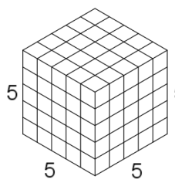 | Cubes  The volume of a cube can be described as e³, where e is the length of an edge of the cube. The length, width, and height of a cube are all the same, so multiplying the length, width, and height is the same as cubing any one of those measurements.  In this case, the volume = 5 · 5 · 5 = 5³ = 125 cubic units
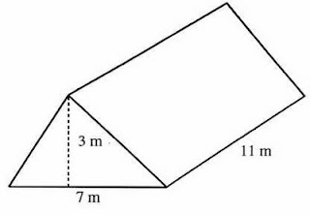 | Triangular Prisms  The volume of a triangular prism is equal to the area of one of the triangular bases times the length of the prism.  In this case, the area of each base equals $\frac{1}{2}$ (7 · 3),  so the volume = $\frac{1}{2}$ (7 · 3) · 11 = 115.5 m³
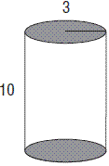 | Cylinders  The volume of a cylinder is equal to the area of one of the circular bases times the height of the cylinder.  In this case, the area of each base equals π(3)² or 9π,  so the volume = 9π · 10 = 90π cubic units

Surface Area
The surface area of a solid is the area of each of the solid’s surfaces added together.
Surface area is often used in construction. If you need to paint any 3‐D object you need to know how much paint to buy. The keys to success with surface area problems: make sure that you have the correct measurements and that you don't leave any surfaces out in your calculations.
Surface Area of a Rectangular Prism
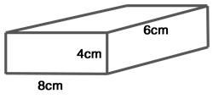
If we "unfold" the box, we get something that is called – in the geometry world – a "net".
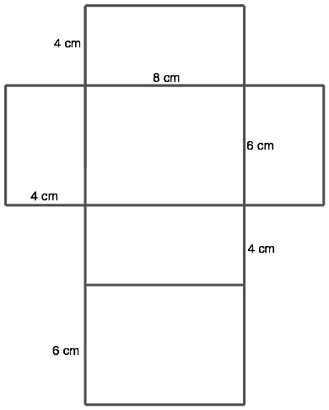
Using the net we can see that there are six rectangular surfaces.
Side 1 | 4 x 8 | 32 cm² | If we study the table we will see that there are two of each surface. That's because the top and bottom of a rectangular prism are congruent, as are the two sides, and the front and back.
Side 2 | 8 x 6 | 48 cm²
Side 3 | 4 x 8 | 32 cm²
Side 4 | 8 x 6 | 48 cm²
Side 5 | 4 x 6 | 24 cm²
Side 6 | 4 x 6 | 24 cm²
 | Total | 208 cm²
Surface Area of a Triangular Prism

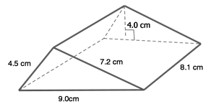
If we break down our triangular prism into a net, it looks like this:
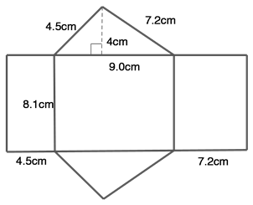
In a triangular prism there are five sides, two triangles and three rectangles.
Side 1 | ½(9 × 4) | 18 cm2
Side 2 | ½(9 × 4) | 18 cm²
Side 3 | 4.5 x 8.1 | 36.45 cm²
Side 4 | 9 x 8.1 | 72.9 cm²
Side 5 | 7.2 x 8.1 | 58.32 cm²
 | Total | 203.67 cm²

Surface Area of a Cylinder
Imagine a can of soup. | If we use a can opener and cut off the top and bottom, and unroll the middle section, we would get:
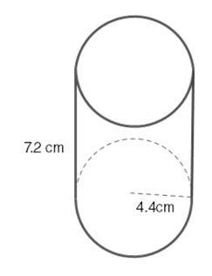 | 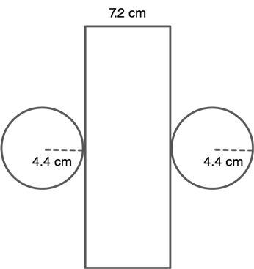
Now you can see that we have two congruent circles, each with a radius of 4.4 cm and a rectangle with a width of 7.2 cm. The only measurement we are missing is the length. Remember when we unrolled the center section. Well, its length was wrapped around the circles, so it's the perimeter of the circle, i.e., the circumference. Therefore, we must find the circumference of a circle with radius 4.4 cm.
Circumference of a circle = dπ = (4.4 × 2)π = 8.8π
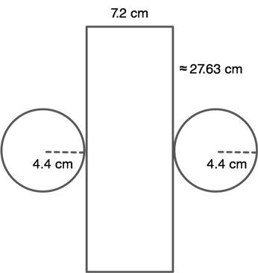
Now, we can solve for surface area:
Circle 1 | 4.4² × π | 19.36π cm²
Circle 2 | 4.4² × π | 19.36π cm²
Center | 8.8π x 7.2 | 63.36π cm²
 | Total | 102.08π cm²

